Wuhan Institute of Technology
International College
"Introduction to Artificial Intelligence" Experiment report
Professional Classes |  |  | Lab time
Student number |  | 2314012019 | Location of the experiment
Student name |  | HASAN IKBAL | Faculty advisor |  | Yellow Blue
Lab projects |  | Design and implementation of search algorithm
Experiment Category |  | Designability | Lab hours |  | 4
Purpose and requirements of the experiment |  | Purpose of the experiment:  1. Master the configuration of Python programming environment and the basic syntax of Python  2. Realize classical search algorithms through programming, including depth-first and breadth-first search algorithms, and deepen the understanding of artificial intelligence algorithms.  Experimental requirements:  - Clearly state the configuration process of the Python programming environment. Include Anaconda, Pycharm, and the corresponding library installation.  - Specify the Numpy grammar learning process, including experimental code and results display.  - Explain the principles of breadth-first and depth-first search algorithms.  - Realize the construction of graph theory data set, the code of width first and depth first search algorithm. Write the code steps and show the results.
An achievement review sheet
Class |  | Scoring criteria |  | Scoring Values |  | Points scored | Combined score
Computer performance |  | Show up on time and be disciplined  Complete all experiments carefully |  | 30 points
Quality of report | Program code standard, function correct  Fill in the content complete, reflect the harvest |  |  | 70 points
Instructions:
Evaluation Teacher:
Date: Month, 2023

The experimental report gives the content elements in the following order:
- Procedure flow chart
- Experimental results and analysis diagram
  - The configuration process of Python programming environment. Including Pycharm and corresponding algorithm library installation.
  - Python Numpy syntax learning process, including experimental code and results show.
  - Explain the principles of breadth-first and depth-first search algorithms.
  - The code of graph theory data set construction, breadth-first and depth-first search algorithm. Write the code steps and show the results.
  - Compare the results of different search algorithms.
- Source code and necessary comments
- Experimental summary and experience
Note: The experiment report is required to be completed independently, and students are allowed to discuss with each other, but plagiarism is absolutely not allowed. Once found, this experiment is recorded as 0 points.
1. Procedure flow chart
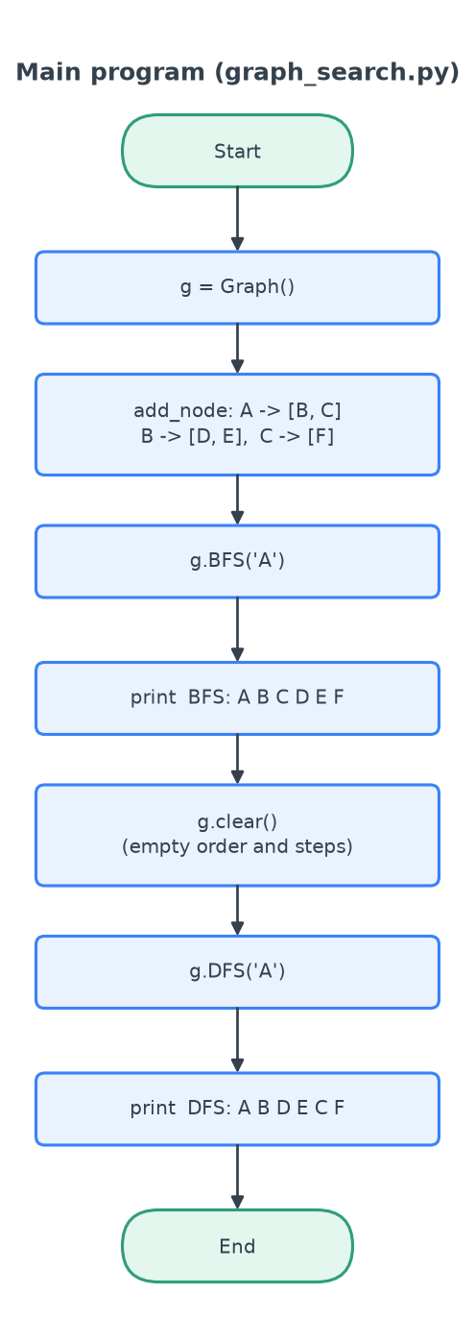
Figure 1: Flow chart of the main program (graph_search.py)
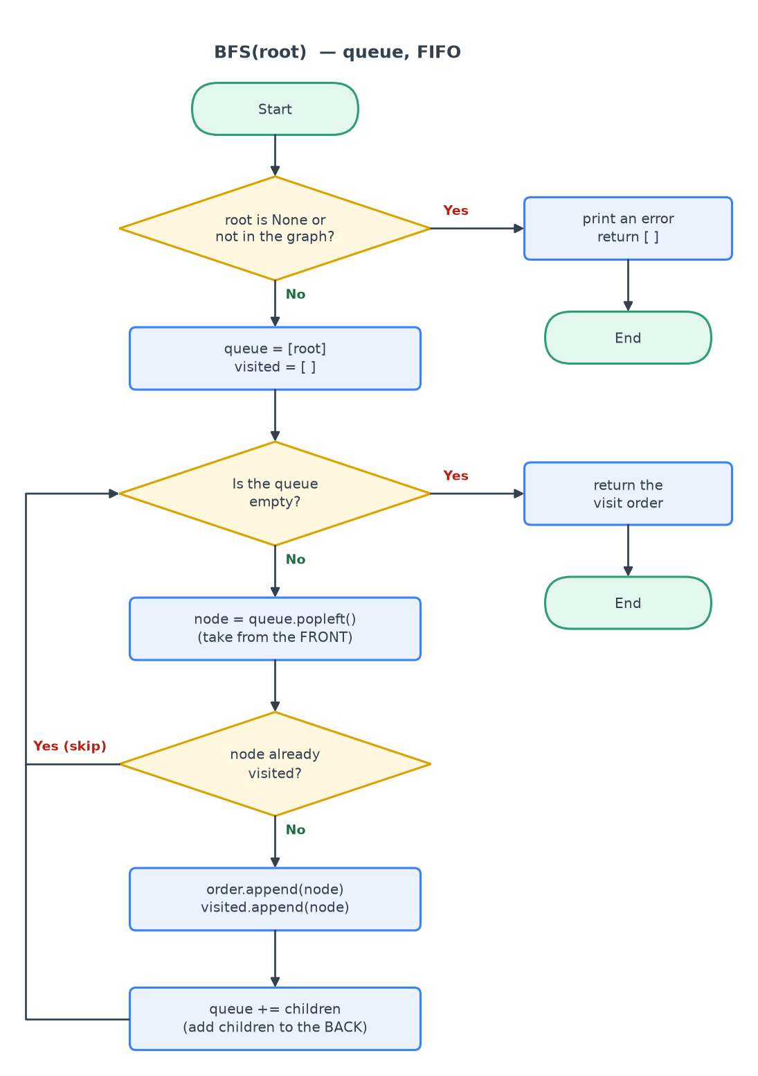
Figure 2: Flow chart of BFS (queue, FIFO)
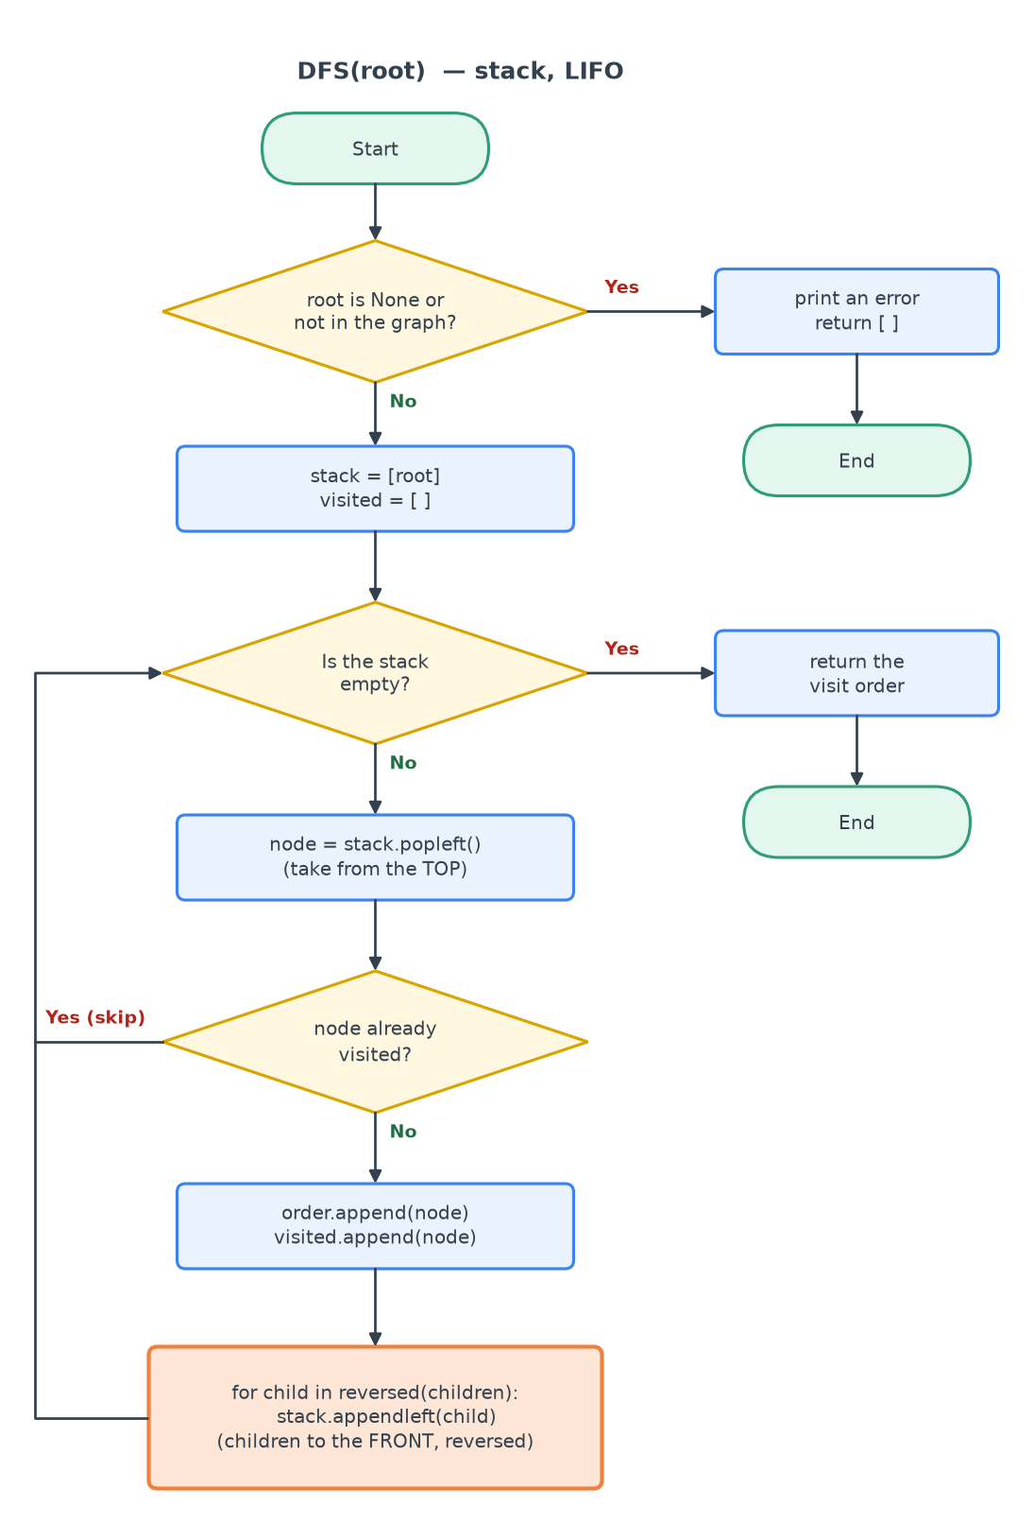
Figure 3: Flow chart of DFS (stack, LIFO). The orange box is the only difference from BFS
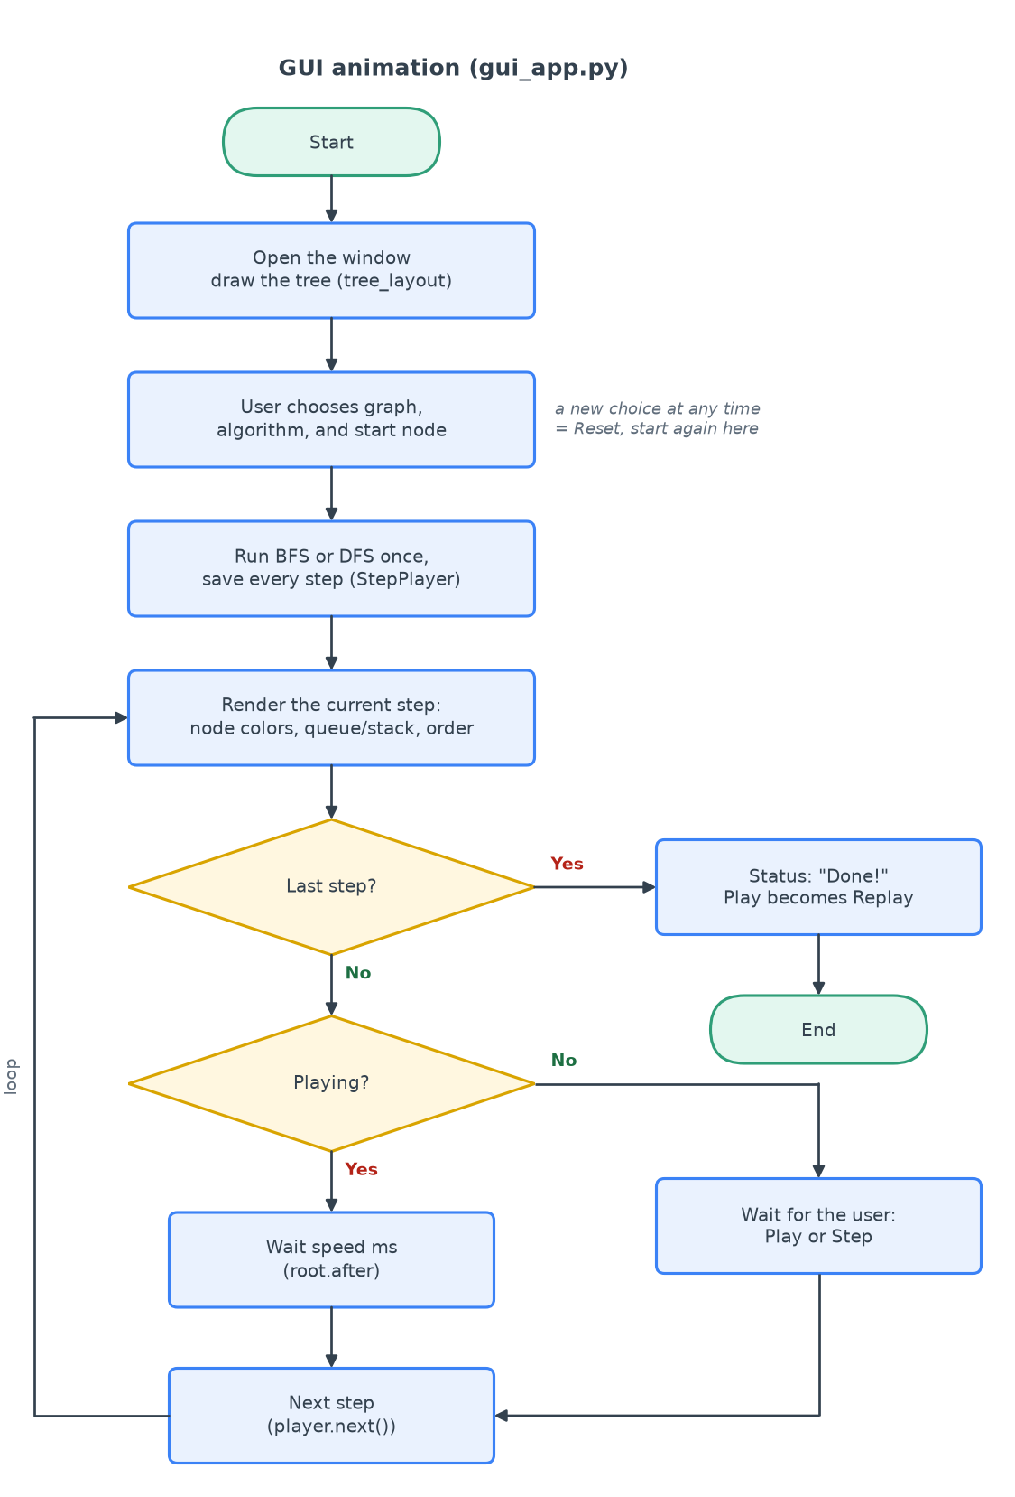
Figure 4: Flow chart of the GUI animation (gui_app.py)
Figure 1 shows the main program: it builds the graph, runs BFS, prints the visit order, clears the result, then runs DFS and prints again. Figures 2 and 3 show the search loop. At the start, the root node is put into the container. In each round, the program takes one node out, checks if it was visited before, adds it to the visit order, and puts its children into the container. The loop stops when the container is empty. BFS and DFS have the same loop. The only different box is the orange box in Figure 3: BFS adds the children to the back of a queue, but DFS adds them to the front of a stack (in reversed order). Figure 4 shows the GUI: it saves every step of the search and then shows the steps one by one with a timer.
2. Experimental results and analysis diagram
2.1 Console output
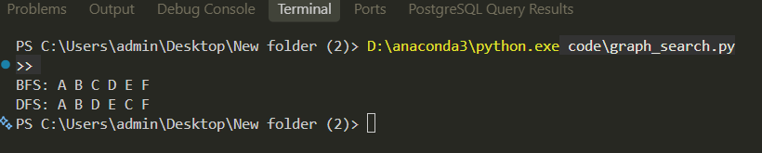
Figure 5: Output of graph_search.py: BFS and DFS on the teacher's tree
Table 1: Search results on the teacher's tree
Algorithm | Visit order | Expected | Correct?
BFS | A B C D E F | A B C D E F | Yes
DFS | A B D E C F | A B D E C F | Yes

2.2 GUI: BFS and DFS animation
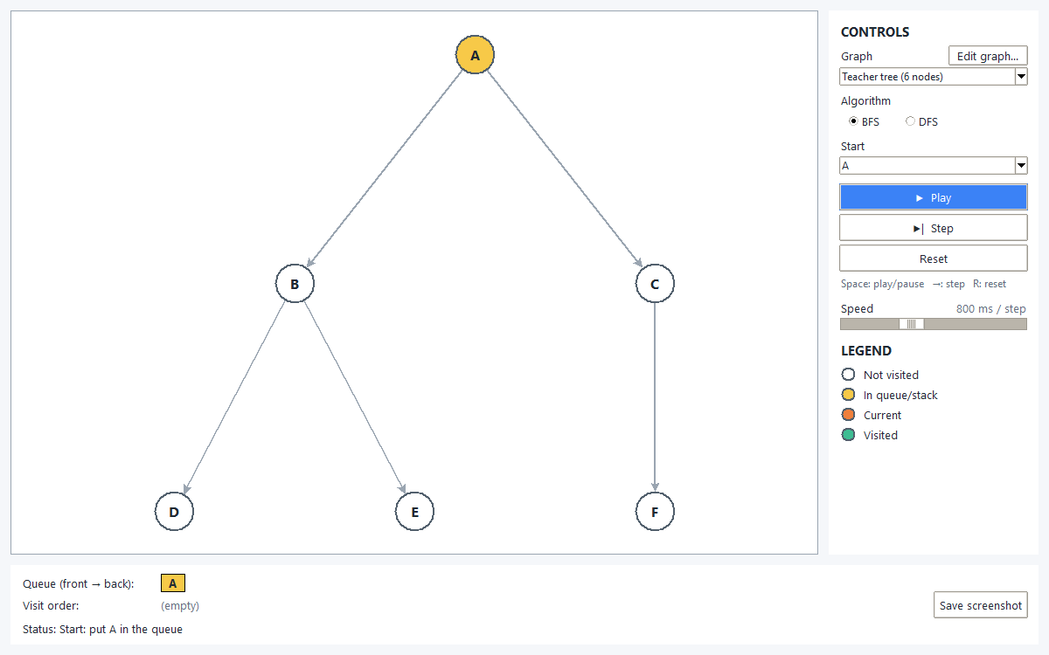
Figure 6: GUI at the start: A is in the queue (yellow)
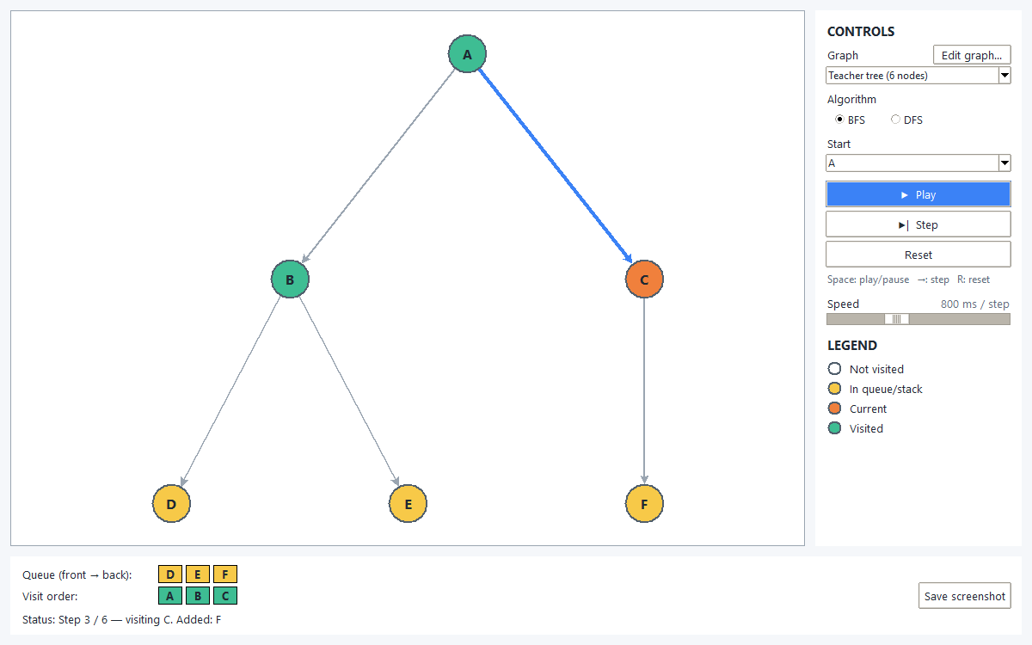
Figure 7: BFS, step 3: visiting C (orange), queue = [D, E, F]
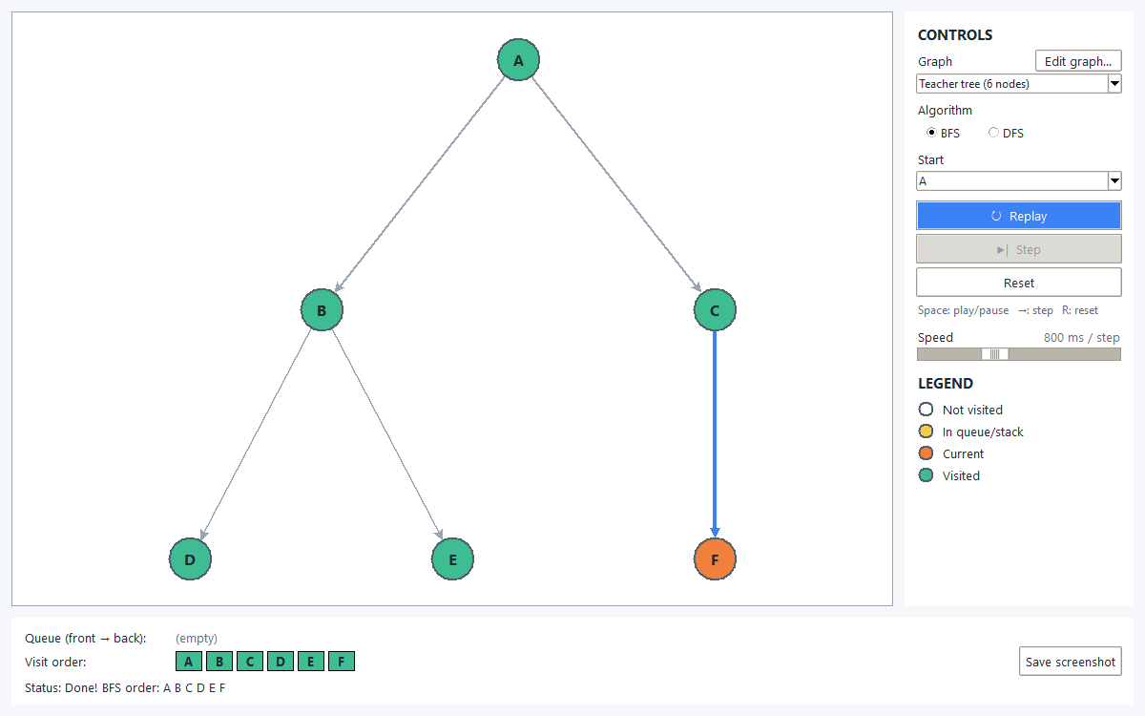
Figure 8: BFS finished: A B C D E F
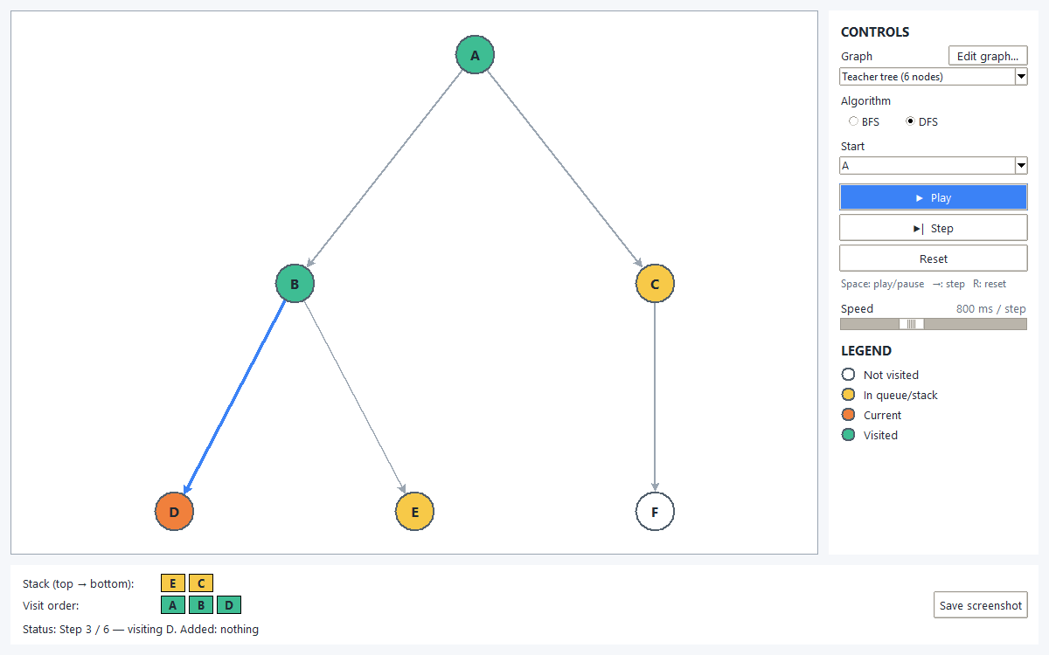
Figure 9: DFS, step 3: visiting D, stack = [E, C]
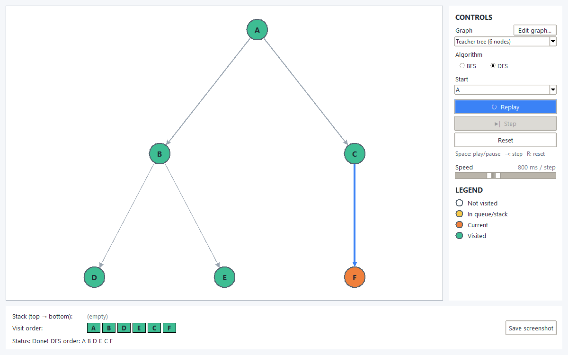
Figure 10: DFS finished: A B D E C F
2.3 BFS vs DFS on several graphs
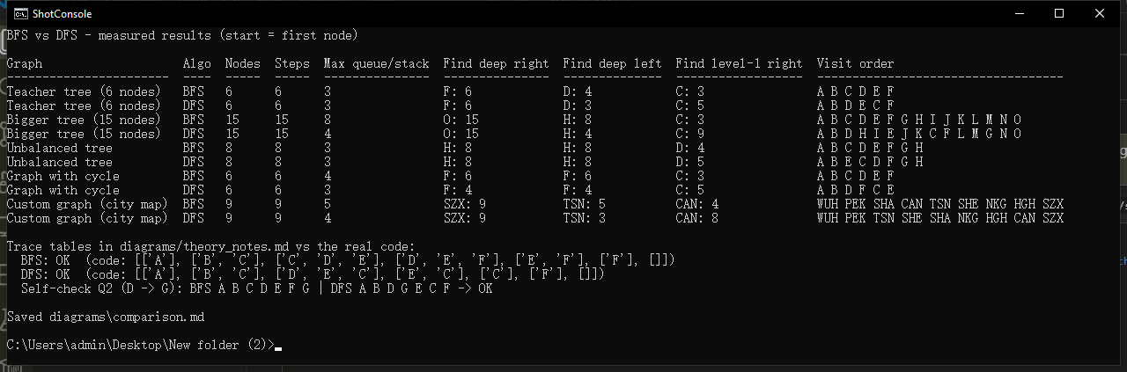
Figure 11: Output of compare.py: BFS and DFS measured on 5 graphs
The visit orders are correct. BFS gives A B C D E F and DFS gives A B D E C F, which are the same as the expected answers in Table 1. In the GUI, the colors help me see the search: white nodes are not visited yet, yellow nodes are waiting in the queue or stack, the orange node is the current node, and green nodes are finished. The boxes under the tree show the queue or stack after each step. For example, in BFS step 3 the queue is [D, E, F], so the next nodes come level by level. In DFS step 3 the stack is [E, C], so the search goes deep into the B branch first and visits C later. Figure 11 shows that the program also works on bigger graphs and on a graph with a cycle, and every node is visited only one time.
3. Configuration of the Python programming environment
• Step 1: Download Anaconda (Python distribution with NumPy and Matplotlib) from anaconda.com.
• Step 2: Install Anaconda 2026.07-1 to D:\anaconda3 (drive C: had too little free space).
• Step 3: Check in the Anaconda Prompt: python --version, conda --version, conda list numpy.
• Step 4: Install PyCharm to D:\PyCharm.
• Step 5: In PyCharm: open the project, set the interpreter to the Conda base environment (D:\anaconda3).
• Step 6: Run code/check_env.py: numpy 2.4.6, matplotlib 3.11.0, tkinter 8.6 and Pillow 12.2.0 all OK.

Figure 12: Anaconda download page

Figure 13: Anaconda installer
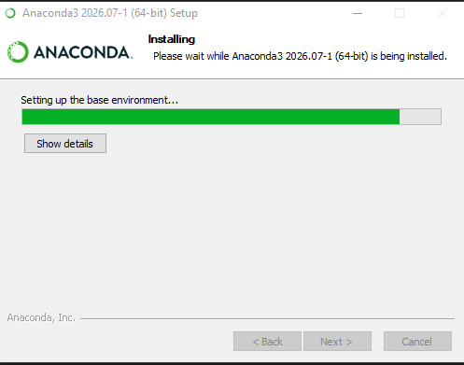
Figure 14: Anaconda installing the base environment
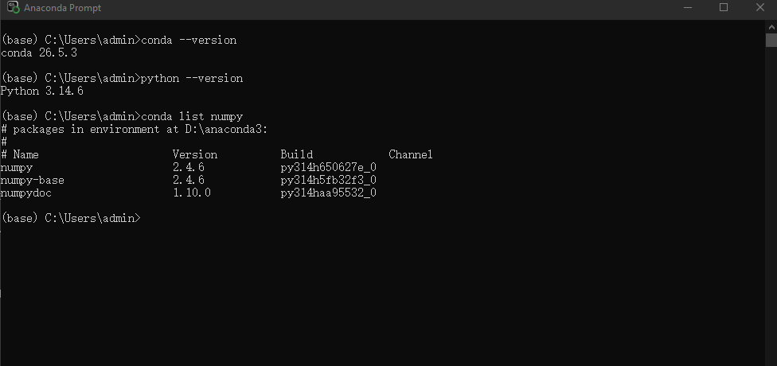
Figure 15: Python and conda versions in the Anaconda Prompt
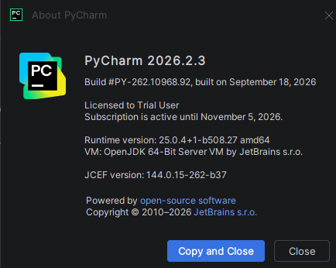
Figure 16: PyCharm installed
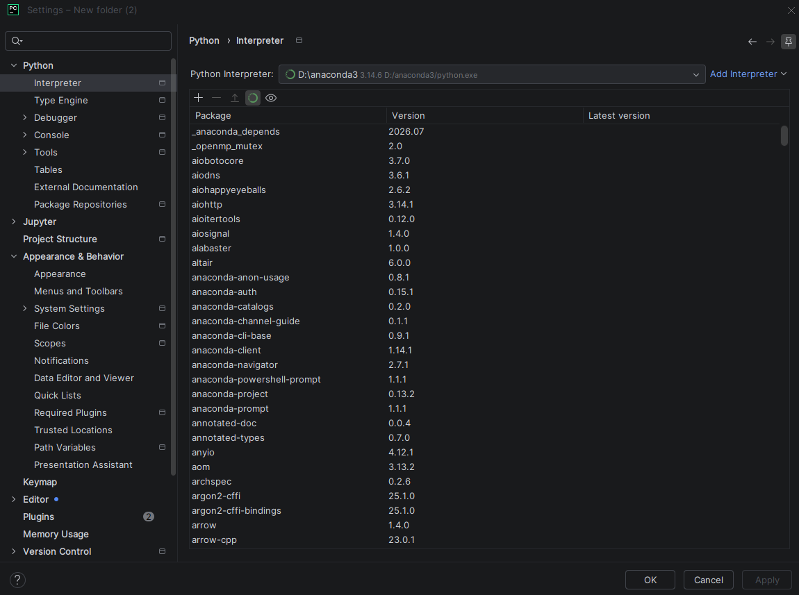
Figure 17: PyCharm project interpreter = Anaconda
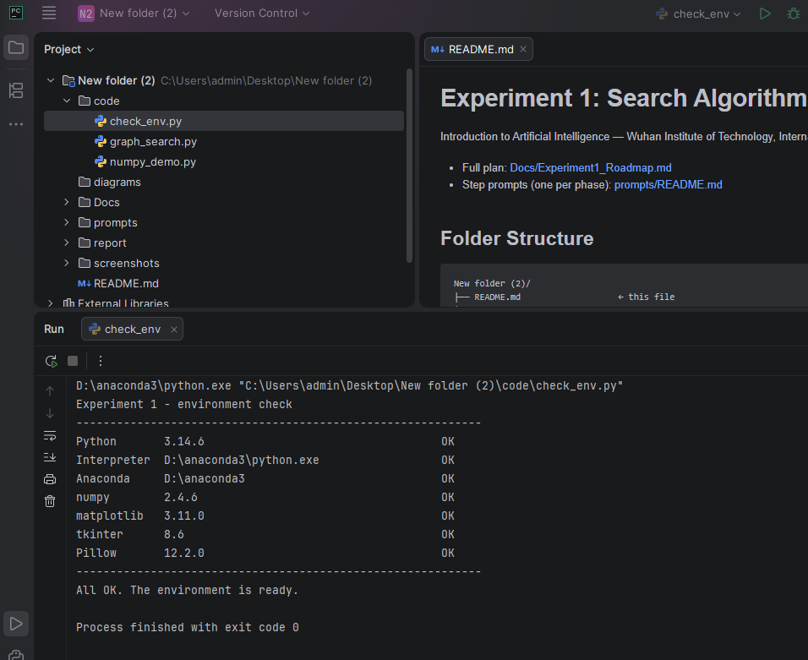
Figure 18: check_env.py: all libraries OK
First I downloaded Anaconda, because it already has Python, NumPy and Matplotlib. My C: drive was almost full, so I installed Anaconda to D:\anaconda3 and PyCharm to D:\PyCharm. Anaconda was not added to PATH, so in the terminal I run my scripts with the full path D:\anaconda3\python.exe. In PyCharm I opened the project folder and chose the Conda base environment as the interpreter. At the end I ran check_env.py, and it showed that NumPy, Matplotlib, Tkinter and Pillow all work.
4. Python NumPy syntax learning process
Code: code/numpy_demo.py (each topic is one function; run one topic with numpy_demo.py <number>).
4.1 Create arrays
def section_1_create_arrays():
show("np.array([1, 2, 3])", np.array([1, 2, 3]))
show("np.array([[1, 2, 3], [4, 5, 6]])", np.array([[1, 2, 3], [4, 5, 6]]))
show("np.array([1, 2, 3, 4], float)", np.array([1, 2, 3, 4], float))
show("np.zeros((3, 4))", np.zeros((3, 4)))
show("np.ones((2, 3), dtype='float64')", np.ones((2, 3), dtype="float64"))
# empty() only reserves memory, so the values are whatever was there before.
# Slide fix: np.int was removed from NumPy, use int.
show("np.empty((2, 3), int)", np.empty((2, 3), int))
show("np.arange(1, 20, 5)", np.arange(1, 20, 5))
show("np.arange(0, 1, 0.1)", np.arange(0, 1, 0.1))
show("np.linspace(0, 1, 10)", np.linspace(0, 1, 10))
show("np.linspace(0, 1, 10, endpoint=False)", np.linspace(0, 1, 10, endpoint=False))
show("np.logspace(0, 2, 5)", np.logspace(0, 2, 5))
show("np.full(4, np.pi)", np.full(4, np.pi))

def func(i):
return i % 4 + 1

# fromfunction calls func with the index of every element.
show("np.fromfunction(func, (10,)) # func(i) = i % 4 + 1",
np.fromfunction(func, (10,)))
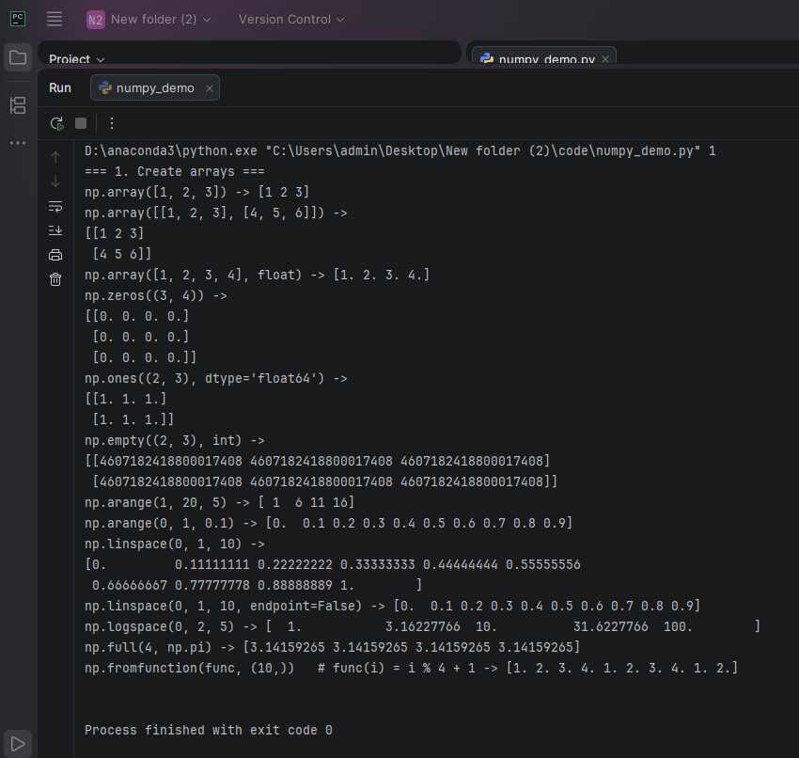
Figure 19: Output of Create arrays
4.2 Array properties
def section_2_properties():
data = np.arange(12).reshape(3, 4)
show("data = np.arange(12).reshape(3, 4)", data)
show("type(data)", type(data))
show("data.shape", data.shape)
show("data.size", data.size)
# The slide shows int32: old NumPy on Windows used 32-bit int, NumPy 2 uses 64-bit.
show("data.dtype", data.dtype)
show("data.ndim", data.ndim)

a = np.array([1, 2, 3, 4], dtype=float)
show("a = np.array([1, 2, 3, 4], dtype=float); a.dtype", a.dtype)
# Slide fix: a.leshape -> a.reshape
show("a.reshape((2, 2))", a.reshape((2, 2)))
# -1 means "work out this size for me" (here 4 / 1 = 4 rows).
show("a.reshape(-1, 1)", a.reshape(-1, 1))
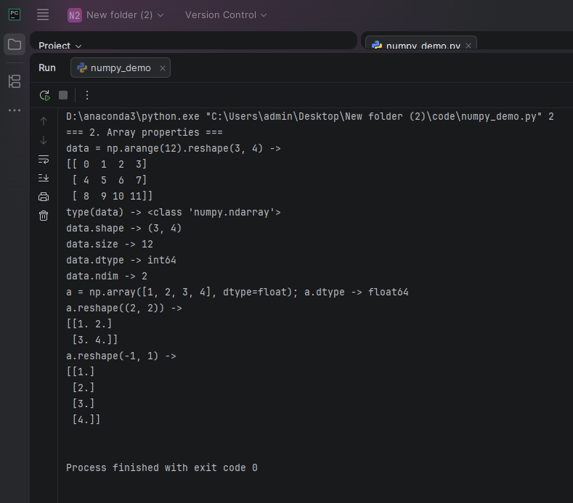
Figure 20: Output of Array properties
4.3 Slicing
def section_3_slicing():
a = np.arange(10)
show("a = np.arange(10)", a)
show("a[5], a[3:5], a[:5], a[:-1]", a[5], a[3:5], a[:5], a[:-1])
show("a[1:-1:2], a[::-1], a[5:1:-2]", a[1:-1:2], a[::-1], a[5:1:-2])

a[2:4] = 100, 101
show("a[2:4] = 100, 101; a", a)

# A slice is a VIEW: b and a share the same memory, so changing b changes a.
b = a[3:7]
b[2] = -10
show("b = a[3:7]; b[2] = -10; a", a)

# A list index makes a COPY: changing b does not change a.
a = np.arange(10)
b = a[[3, 3, -3, 8]]
b[2] = 100
show("a = np.arange(10); b = a[[3, 3, -3, 8]]; b[2] = 100; b, a", b, a)

m = np.arange(0, 60, 10).reshape(-1, 1) + np.arange(0, 6)
show("m = np.arange(0, 60, 10).reshape(-1, 1) + np.arange(0, 6)", m)
show("m[0, 3:5]", m[0, 3:5])
show("m[4:, 4:]", m[4:, 4:])
show("m[2::2, ::2]", m[2::2, ::2])
# Integer lists and Boolean arrays also make copies (slide 21).
show("m[[0, 2, 5], [1, 3, 5]]", m[[0, 2, 5], [1, 3, 5]])
show("m[m % 20 == 0]", m[m % 20 == 0])
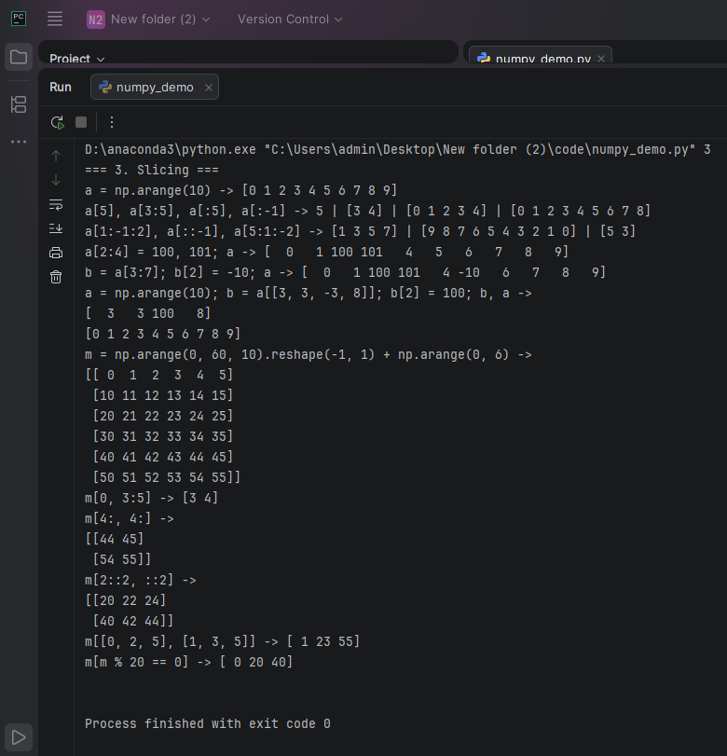
Figure 21: Output of Slicing
4.4 Struct array
def section_4_struct_array():
# Slide fix: 'S30' stores bytes (prints b'Zhang'), 'U30' stores normal text.
persontype = np.dtype({
"names": ["name", "age", "weight"],
"formats": ["U30", "i", "f"],
})
show("persontype", persontype)

# Slide fix: np. Array -> np.array, and "." before dtype -> ","
a = np.array([("Zhang", 32, 75.5), ("Wang", 24, 65.2)], dtype=persontype)
show("a", a)
# Slide fix: print a[0] -> print(a[0])
show("a[0]", a[0])
show("a['name']", a["name"])
show("a[1]['age']", a[1]["age"])
show("a['weight'].mean()", a["weight"].mean())
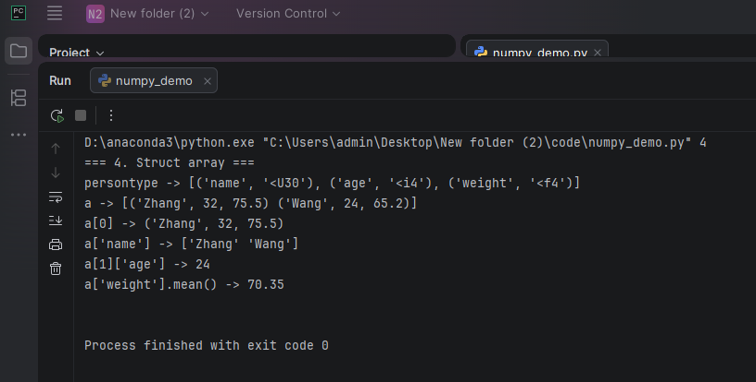
Figure 22: Output of Struct array
4.5 ufunc (universal functions)
def section_5_ufunc():
x = np.linspace(0, 2 * np.pi, 10)
# The last value prints as -0. : sin(2*pi) is really about -2.4e-16 (rounding error).
with np.printoptions(precision=3, suppress=True):
show("np.sin(np.linspace(0, 2 * np.pi, 10))", np.sin(x))

a = np.arange(0, 4)
b = np.arange(1, 5)
show("a = np.arange(0, 4); b = np.arange(1, 5)", a, b)
show("np.add(a, b) (same as a + b)", np.add(a, b))
show("np.subtract(a, b)", np.subtract(a, b))
show("np.multiply(a, b)", np.multiply(a, b))
# In Python 3 / NumPy 2, divide always gives floats (the slide is from Python 2).
show("np.divide(a, b)", np.divide(a, b))
show("np.power(a, b)", np.power(a, b))

show("np.array([1, 2, 3]) < np.array([3, 2, 1])",
np.array([1, 2, 3]) < np.array([3, 2, 1]))
show("np.less_equal([1, 2, 3], [3, 2, 1])", np.less_equal([1, 2, 3], [3, 2, 1]))

def num_judge(x, a):
"""Return 0 if x is a multiple of 3 or 5, otherwise return a."""
if x % 3 == 0:
r = 0
elif x % 5 == 0:
r = 0
else:
r = a
return r

# frompyfunc(func, nin, nout) turns a normal Python function into a ufunc.
numb_judge = np.frompyfunc(num_judge, 2, 1)
x = np.linspace(0, 10, 11)
y = numb_judge(x, 2)
show("numb_judge = np.frompyfunc(num_judge, 2, 1); numb_judge(x, 2)", y)
# Slide fix: y.astype(np.int) -> y.astype(int)
show("y.astype(int)", y.astype(int))
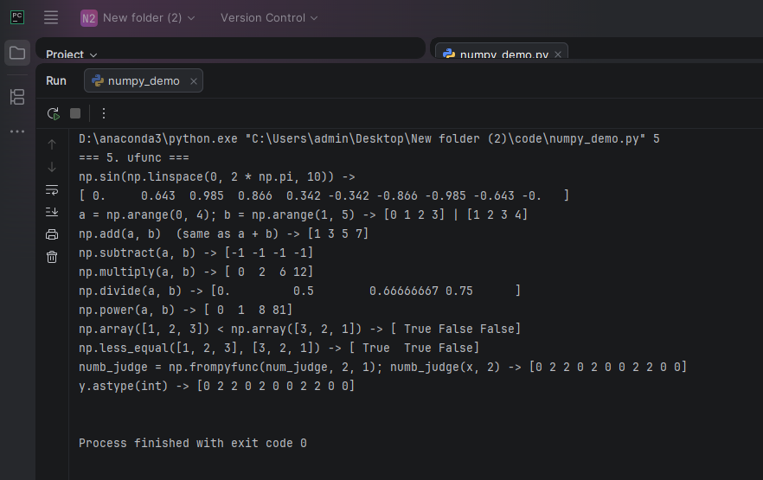
Figure 23: Output of ufunc (universal functions)
4.6 Broadcasting
def section_6_broadcasting():
a = np.arange(0, 60, 10).reshape(-1, 1)
b = np.arange(0, 5)
show("a = np.arange(0, 60, 10).reshape(-1, 1) (shape (6, 1))", a)
show("b = np.arange(0, 5) (shape (5,))", b)
# a is stretched to 5 columns and b to 6 rows, so the result is 6 x 5.
c = a + b
show("c = a + b", c)
show("c.shape", c.shape)

x, y = np.ogrid[:5, :5]
show("x, y = np.ogrid[:5, :5]; x", x)
show("y", y)
show("x + y", x + y)

a = np.arange(4)
# Slide fix: a.Rishape -> a.reshape. None adds a new axis of size 1.
show("a[None, :] (same as a.reshape(1, -1))", a[None, :])
show("a[:, None] (same as a.reshape(-1, 1))", a[:, None])
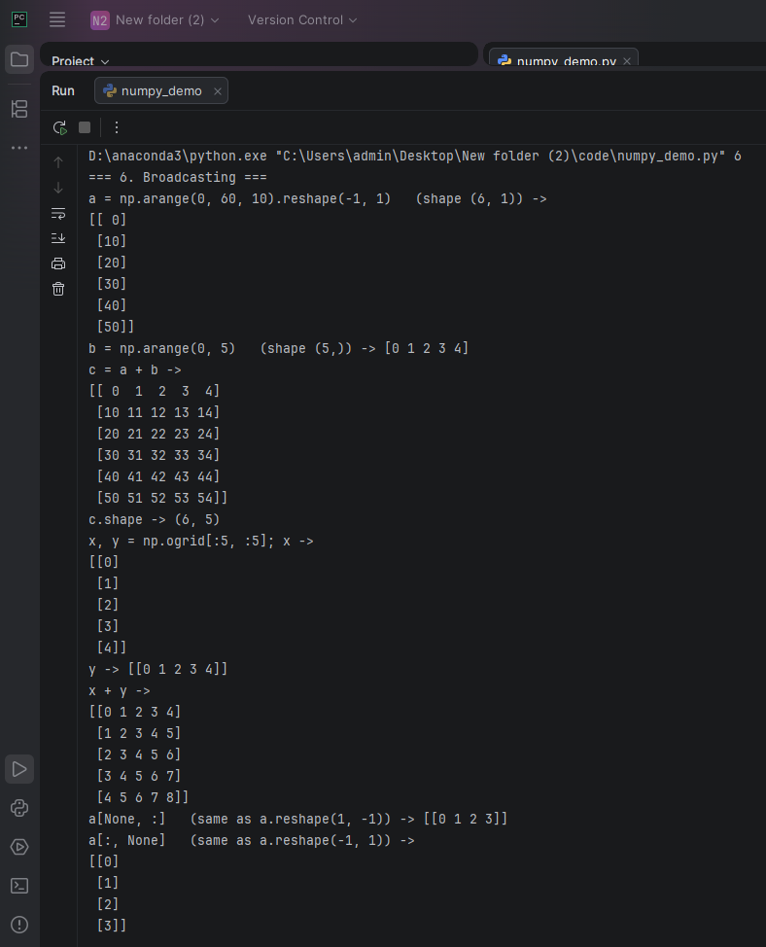
Figure 24: Output of Broadcasting
4.7 Random numbers
def section_7_random():
# Same seed -> same "random" numbers every run, so the output can be checked.
np.random.seed(42)
with np.printoptions(precision=2):
show("np.random.rand(4, 3)", np.random.rand(4, 3))
show("np.random.randint(0, 10, size=(2, 5))", np.random.randint(0, 10, size=(2, 5)))
show("np.random.normal(0, 1, 5)", np.random.normal(0, 1, 5))
show("np.random.randn(5)", np.random.randn(5))
show("np.random.uniform(1, 3, 5)", np.random.uniform(1, 3, 5))
show("np.random.poisson(2.0, (4, 3))", np.random.poisson(2.0, (4, 3)))
show("np.random.choice([10, 20, 30, 40], 3)", np.random.choice([10, 20, 30, 40], 3))
a = np.arange(10)
np.random.shuffle(a)
show("a = np.arange(10); np.random.shuffle(a); a", a)
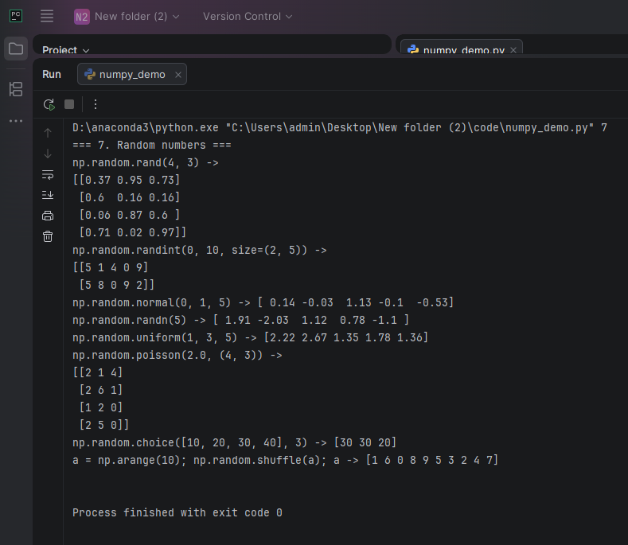
Figure 25: Output of Random numbers
4.8 Statistics
def section_8_statistics():
np.random.seed(42)
a = np.random.randint(0, 10, size=(4, 5))
show("np.random.seed(42); a = np.random.randint(0, 10, size=(4, 5))", a)
show("np.sum(a)", np.sum(a))
show("np.sum(a, axis=1), np.sum(a, axis=0)", np.sum(a, axis=1), np.sum(a, axis=0))
show("np.sum(a, 1, keepdims=True)", np.sum(a, 1, keepdims=True))
show("np.mean(a), np.var(a), np.std(a)", np.mean(a), np.var(a), round(np.std(a), 4))
show("np.min(a), np.max(a), np.ptp(a), np.argmin(a), np.median(a)",
np.min(a), np.max(a), np.ptp(a), np.argmin(a), np.median(a))
show("np.sort(a) (sort each row)", np.sort(a))
show("np.sort(a, axis=0) (sort each column)", np.sort(a, axis=0))
show("np.argsort([30, 10, 20])", np.argsort([30, 10, 20]))

b = np.array([1, 3, 5, 7])
c = np.array([2, 4, 6])
# Slide fix: maxinum -> maximum
show("np.maximum(b[None, :], c[:, None])", np.maximum(b[None, :], c[:, None]))

r = np.abs(np.random.randn(100000))
with np.printoptions(precision=3):
show("np.percentile(abs(randn(100000)), [68.3, 95.4, 99.7])",
np.percentile(r, [68.3, 95.4, 99.7]))

np.random.seed(42)
a = np.random.randint(0, 8, 10)
show("np.random.seed(42); a = np.random.randint(0, 8, 10)", a)
show("np.unique(a)", np.unique(a))
show("np.unique(a, return_index=True)", *np.unique(a, return_index=True))
show("np.unique(a, return_inverse=True)", *np.unique(a, return_inverse=True))
# bincount: result[i] = how many times i appears in a.
show("np.bincount(a)", np.bincount(a))
x = np.array([0, 1, 2, 2, 1, 1, 0])
w = np.array([0.1, 0.3, 0.2, 0.4, 0.5, 0.8, 1.2])
show("np.bincount(x, w) (sum of weights per value)", np.bincount(x, w))

d = np.random.rand(100)
show("np.histogram(np.random.rand(100), bins=5, range=(0, 1))",
*np.histogram(d, bins=5, range=(0, 1)))
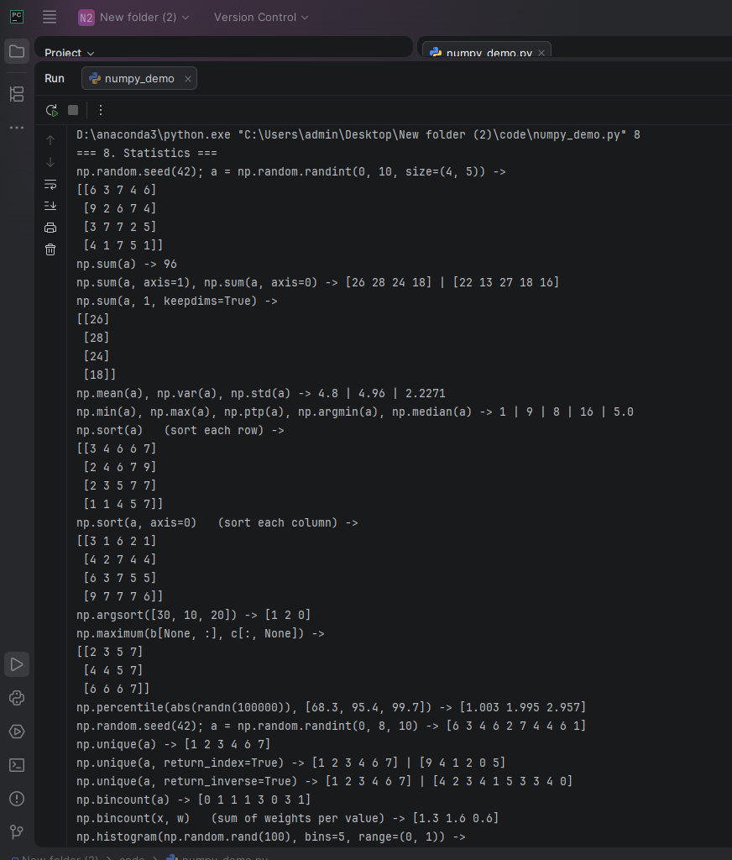
Figure 26: Output of Statistics (part 1)
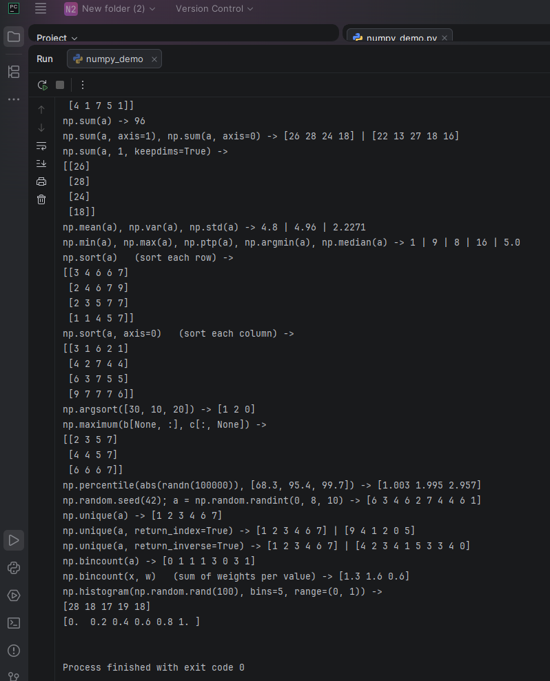
Figure 27: Output of Statistics (part 2)
4.9 Join and split arrays
def section_9_join_split():
a = np.arange(3)
b = np.arange(10, 13)
show("a = np.arange(3); b = np.arange(10, 13)", a, b)
show("np.vstack((a, b)) (one on top of the other)", np.vstack((a, b)))
show("np.hstack((a, b)) (side by side)", np.hstack((a, b)))
show("np.column_stack((a, b)) (each array becomes a column)", np.column_stack((a, b)))

a = np.array([6, 3, 7, 4, 6, 9, 2, 6, 7, 4, 3, 7])
# Slide fix: the slide names this list b but then uses idx, and misses a ")".
idx = np.array([1, 3, 6, 9, 10])
show("a", a)
show("np.split(a, [1, 3, 6, 9, 10]) (cut at these positions)", np.split(a, idx))
show("np.split(a, 2) (cut into 2 equal parts)", np.split(a, 2))
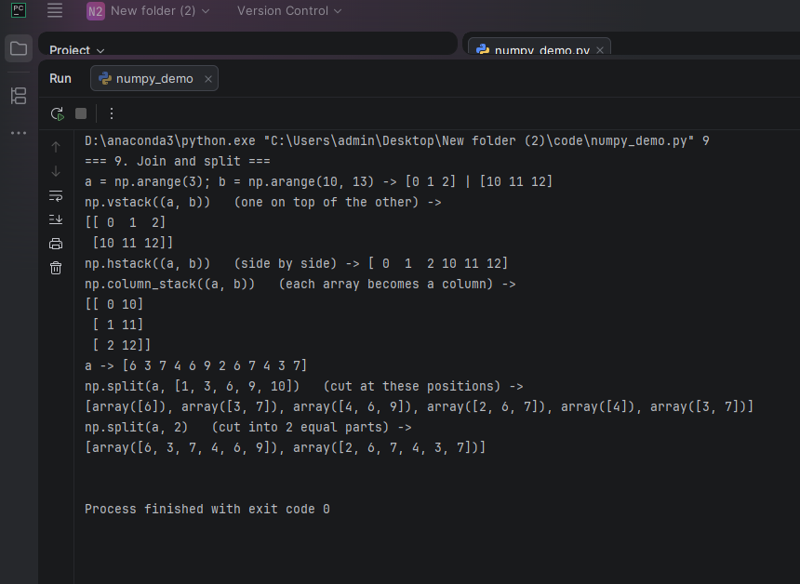
Figure 28: Output of Join and split arrays
4.10 Polynomials
def section_10_polynomials():
# Coefficients go from the highest power down: x^3 + 0x^2 - 2x + 1
p = np.poly1d(np.array([1.0, 0, -2, 1]))
show("p = np.poly1d([1.0, 0, -2, 1]); print(p)", p)
# Slide fix: print type(p) -> print(type(p))
show("type(p)", type(p))
show("p(np.linspace(0, 1, 5))", p(np.linspace(0, 1, 5)))
show("p + [-2, 1]", repr(p + [-2, 1]))
show("p * p", repr(p * p))
quotient, remainder = p / [1, 1]
show("quotient, remainder = p / [1, 1]", repr(quotient), repr(remainder))
show("p.deriv()", repr(p.deriv()))
show("p.integ()", repr(p.integ()))
show("np.roots(p)", np.roots(p))

# polyfit finds the best polynomial for some points. Points taken from p
# give back p's own coefficients, which proves the fit works.
x = np.linspace(-2, 2, 9)
with np.printoptions(precision=4, suppress=True):
show("np.polyfit(x, p(x), 3) (x = np.linspace(-2, 2, 9))", np.polyfit(x, p(x), 3))
# poly() goes the other way: from roots back to coefficients.
# round() hides tiny rounding errors; "+ 0" turns -0. into 0.
show("np.poly(np.roots(p))", np.round(np.poly(np.roots(p)), 4) + 0)
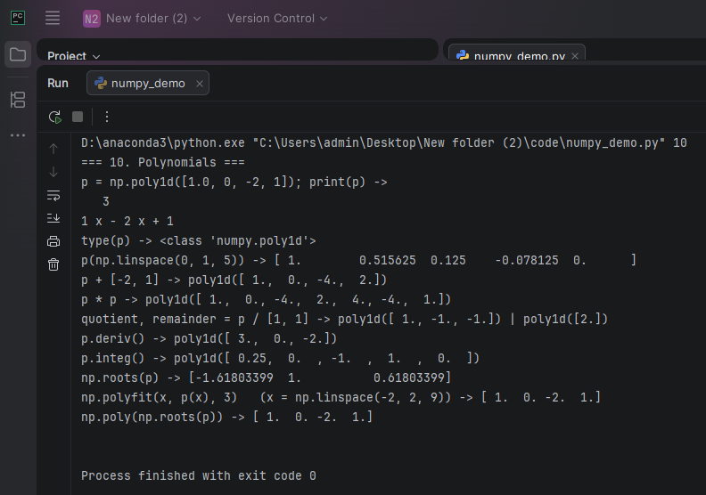
Figure 29: Output of Polynomials
I learned that a NumPy array is faster and easier than a Python list for math, because one operation works on the whole array without a loop (ufunc). I practiced creating arrays, slicing, struct arrays, broadcasting, random numbers, statistics, joining and splitting arrays, and polynomials. Broadcasting was new for me: arrays with different shapes can be added together. I also found that some old code does not work in new NumPy, for example np.int was removed, so I used int, and print x from Python 2 must be print(x).
5. Principles of breadth-first and depth-first search
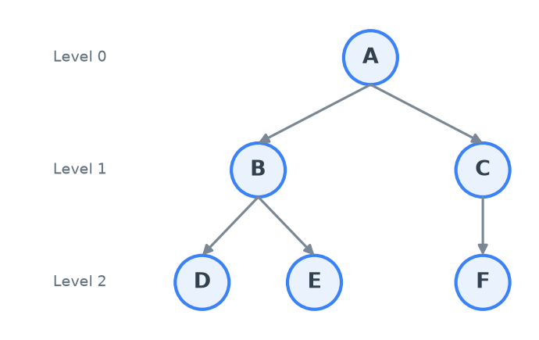
Figure 30: The teacher's tree used in the experiment
5.1 Breadth-first search (BFS)
Breadth-first search uses a queue, which is FIFO (first in, first out). It starts at the root A and visits the graph level by level: first A, then all nodes one step away (B, C), then all nodes two steps away (D, E, F). In every step, BFS takes the node from the front of the queue, visits it, and adds its children to the back of the queue. Table 2 shows this: after visiting B, the queue is [C, D, E], so C (level 1) is visited before D and E (level 2). Because of this, BFS always finds the shortest path (fewest edges) in a graph without weights, but the queue can become large because it keeps a whole level.
Table 2: BFS trace on the teacher's tree (real program steps)
Step | Node taken out | Children added | Queue after (front → back) | Visit order
0 | — (start) | — | [A] | —
1 | A | B, C | [B, C] | A
2 | B | D, E | [C, D, E] | A B
3 | C | F | [D, E, F] | A B C
4 | D | — | [E, F] | A B C D
5 | E | — | [F] | A B C D E
6 | F | — | [] | A B C D E F

5.2 Depth-first search (DFS)
Depth-first search uses a stack, which is LIFO (last in, first out). It starts at the root and goes as deep as possible along one branch. When it reaches a node with no children, it goes back (backtracks) and continues with the next branch. In every step, DFS takes the node from the top of the stack, visits it, and pushes its children on top in reversed order, so the left child is visited first. Table 3 shows this: after visiting B, the stack is [D, E, C], so DFS visits D and E (deep in the B branch) before it goes back to C. DFS needs less memory than BFS, because the stack only keeps one path and the waiting siblings, but the first path it finds is not always the shortest.
Table 3: DFS trace on the teacher's tree (real program steps)
Step | Node taken out | Children added | Stack after (top → bottom) | Visit order
0 | — (start) | — | [A] | —
1 | A | B, C | [B, C] | A
2 | B | D, E | [D, E, C] | A B
3 | D | — | [E, C] | A B D
4 | E | — | [C] | A B D E
5 | C | F | [F] | A B D E C
6 | F | — | [] | A B D E C F

6. Graph data set construction, BFS and DFS code
6.1 Code steps
Table 4: Steps of graph_search.py
Step | Code part | Purpose
1 | from collections import deque | A double-ended queue: a queue for BFS, a stack for DFS
2 | class Graph, __init__ | Stores order (visit list), neighbor (adjacency list), steps
3 | add_node(node) | Adds a node and its list of children
4 | BFS(root) | popleft from the front, add the children to the back
5 | DFS(root) | popleft from the top, push the children to the front, reversed
6 | clear() / node_print() | Reset the result / print the visit order
7 | self.steps | A snapshot of every step, so the GUI can animate the search
8 | if __name__ == '__main__' | Builds the tree, runs BFS, clears, runs DFS

6.2 Building the graph data set
g = Graph()
g.add_node(('A', ['B', 'C']))
g.add_node(('B', ['D', 'E']))
g.add_node(('C', ['F']))
6.3 BFS code
def BFS(self, root):
# First check whether the root node is valid
if not self._root_ok(root):
return []

search_queue = deque()
search_queue.append(root)
visited = []
self._save_step(None, [], search_queue, visited)

while search_queue:
person = search_queue.popleft() # take from the FRONT (FIFO)
# FIX: in a graph with a cycle, a node can be in the queue twice.
# The teacher's code added it to the order again; now we skip it.
if person in visited:
continue
self.order.append(person)
visited.append(person) # FIX: mark leaves visited too

children = self.neighbor.get(person, [])
search_queue += children # add children to the BACK
self._save_step(person, children, search_queue, visited)

return list(self.order)
6.4 DFS code
def DFS(self, root):
# First check whether the root node is valid
if not self._root_ok(root):
return []

search_queue = deque() # used as a stack: the left end is the top
search_queue.append(root)
visited = []
self._save_step(None, [], search_queue, visited)

while search_queue:
person = search_queue.popleft() # take from the TOP (LIFO)
# FIX: skip a node that was already visited (graphs with cycles).
if person in visited:
continue
self.order.append(person)
visited.append(person)

children = self.neighbor.get(person, [])
# FIX: the teacher's tmp.reverse() reversed the stored list itself,
# so the next search used the wrong order. reversed() makes a reversed copy.
# Reverse + push to the front = the leftmost child ends up on top.
for index in reversed(children):
search_queue.appendleft(index)
self._save_step(person, children, search_queue, visited)

return list(self.order)
6.5 Results and tests
Figure 31: Program output
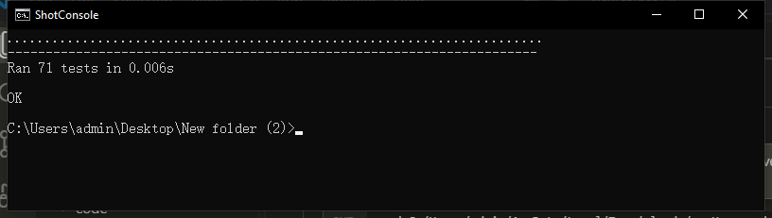
Figure 32: All 71 unit tests pass
6.6 Fixes to the teacher's code
• The slide text has broken indentation, so the code was copied from the code images (slides 14–16).
• DFS: tmp.reverse() reversed the stored children list itself, so the next search used the wrong order. Fixed with reversed(...), which makes a reversed copy.
• add_node printed an error for bad input but still stored it. Now it returns.
• A graph with a cycle could visit a node twice. Fixed with a visited check.
• An unknown start node is now checked (prints a message, returns an empty list).
6.7 Extra: GUI visualizer (Tkinter)
• Draws the graph as a tree; the layout is computed in tree_layout.py.
• Animates BFS and DFS step by step: Play / Pause, Step, Reset, and a Speed slider.
• Colors: white = not visited, yellow = in the queue/stack, orange = current, green = visited.
• Shows the queue/stack and the visit order as boxes under the tree.
• 4 preset graphs (teacher tree, 15-node tree, unbalanced tree, graph with cycle).
• "Edit graph...": type any graph as text (A: B C); bad input shows a clear error.
• Keyboard shortcuts (Space, →, R) and a Save screenshot button.
Table 5: Files of the GUI
File | Job
gui_app.py | The window, drawing, and animation (Tkinter)
sample_graphs.py | Preset graphs + the parser for custom graphs
tree_layout.py | Where each node is drawn (pure Python, tested)
step_player.py | Walks through graph.steps one by one (pure Python, tested)

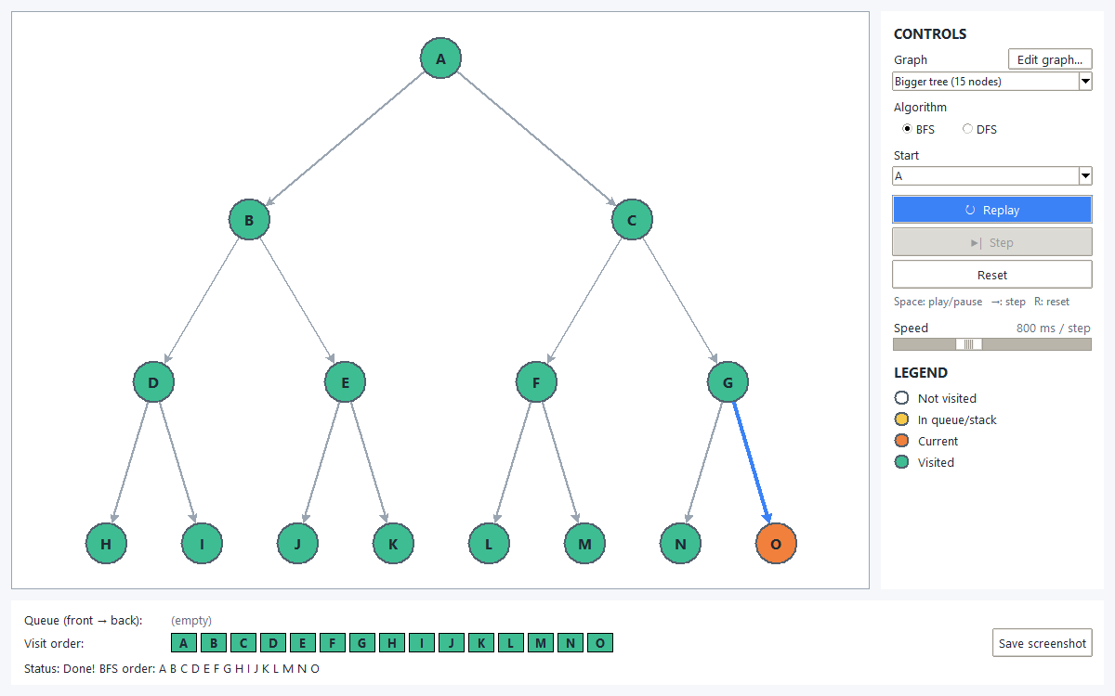
Figure 33: GUI: BFS on the 15-node tree
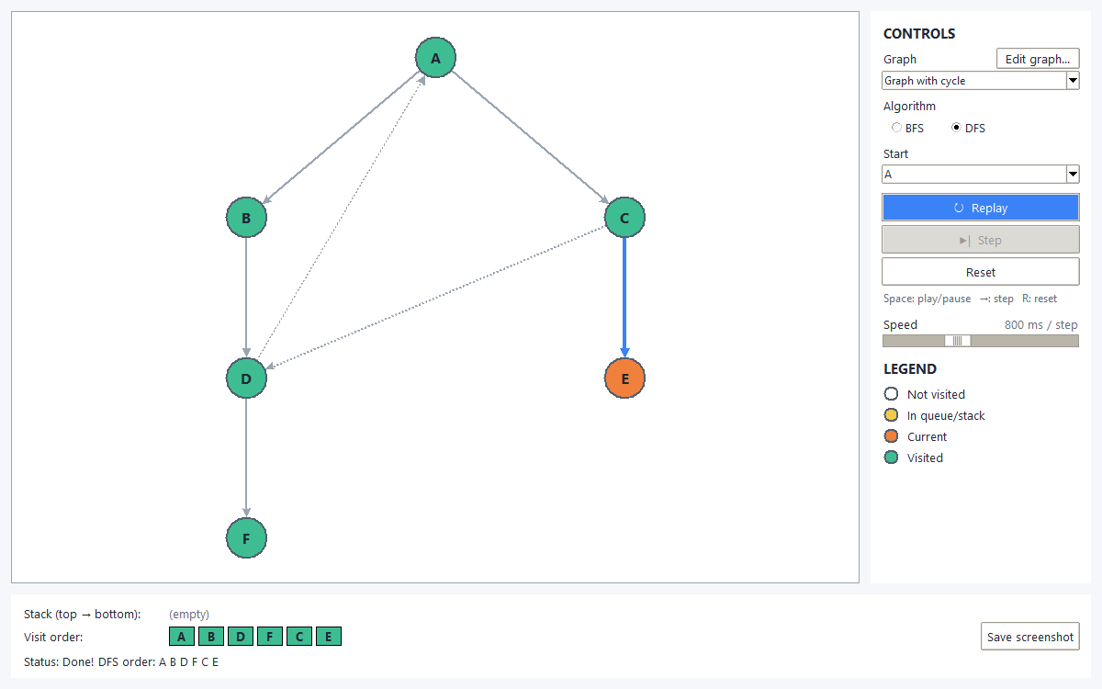
Figure 34: GUI: DFS on the graph with a cycle (dashed edges are not part of the tree)
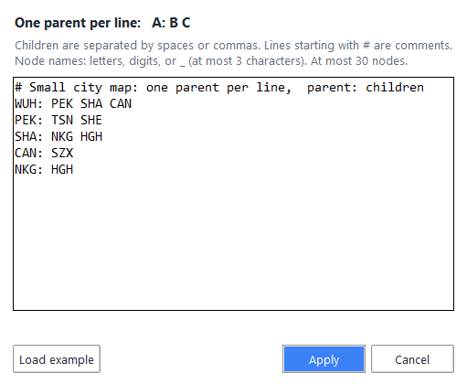
Figure 35: GUI: Edit graph dialog with my own graph (a small map of cities)
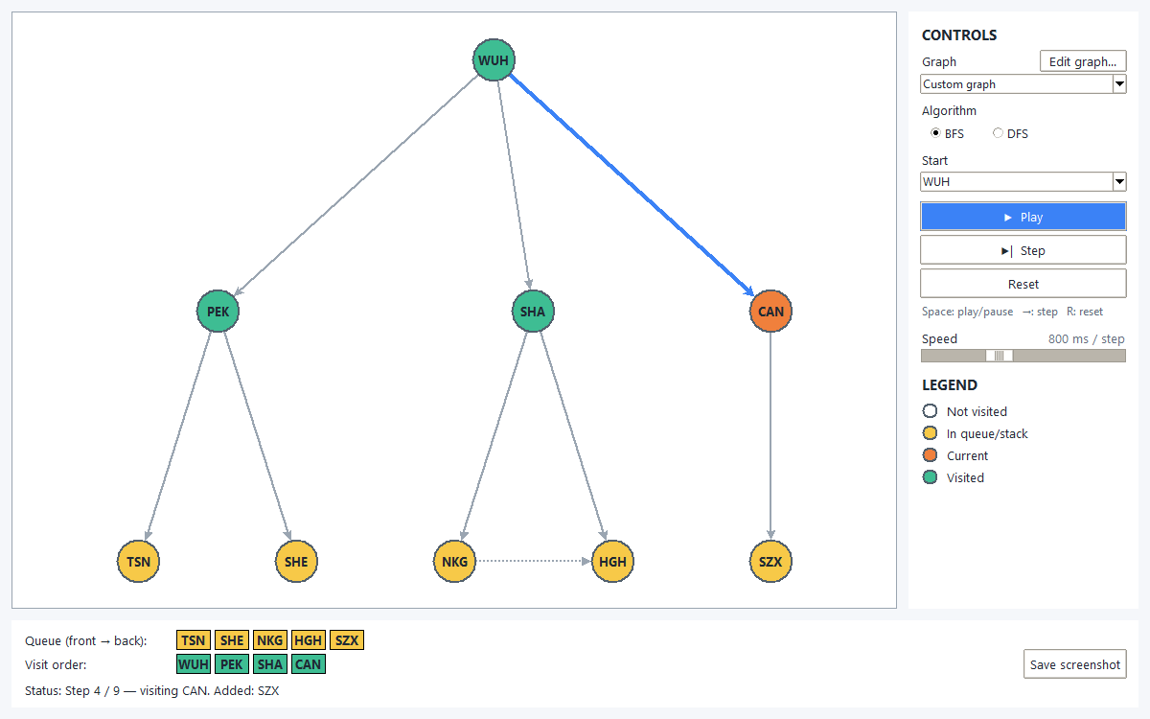
Figure 36: GUI: BFS on the custom city graph
Key GUI code: drawing one step (only the colors change, nothing is redrawn):
def render_step(self):
"""Show the current step: node colors, highlighted edge, boxes, and status."""
step = self.player.current()
if step is None or not self.node_items:
return
current = step["current"]

for node, (circle, _label) in self.node_items.items():
if node == current:
fill = COLORS["current"]
elif node in step["visited"]:
fill = COLORS["visited"]
elif node in step["frontier"]:
fill = COLORS["frontier"]
else:
fill = COLORS["unvisited_fill"]
self.canvas.itemconfigure(circle, fill=fill)

# Highlight only the edge the current node was reached by
for line in self.edge_items.values():
self.canvas.itemconfigure(line, fill=COLORS["edge"], width=2)
edge = self.edge_items.get((self.parents.get(current), current))
if edge is not None:
self.canvas.itemconfigure(edge, fill=COLORS["accent"], width=4)

self._fill_boxes(self.frontier_frame, step["frontier"], COLORS["frontier"])
self._fill_boxes(self.order_frame, step["order"], COLORS["visited"])
self.status_var.set("Status: " + self._status_text(step))
self._update_buttons()
The program uses deque from the collections module. A deque can add and remove items at both ends, so I can use it as a queue for BFS and as a stack for DFS. The Graph class stores the children of every node in a dictionary (neighbor), the visit order in a list (order), and a record of every step (steps). add_node() adds one node with its children list; if the input is wrong, it prints an error and returns. BFS() takes a node from the front with popleft() and adds its children to the back. DFS() also uses popleft(), but adds the children to the front, using reversed() so the original list is not changed. Both functions skip a node that is already visited, so a graph with a cycle does not make an endless loop. In the main part, the program builds the teacher's tree, runs BFS, prints the order, calls clear(), then runs DFS. The GUI uses the saved steps to color the nodes and show the queue or stack one step at a time.
7. Comparison of the search results
Table 6: BFS vs DFS — general comparison
Point | BFS | DFS
Data structure | Queue (FIFO) | Stack (LIFO)
Search style | Level by level | Branch by branch, then backtrack
Memory use | High (a whole level) | Low (one path + waiting siblings)
Shortest path (unweighted)? | Yes | Not always
Time complexity | O(V + E) | O(V + E)
Good for | Shortest path, nearby nodes | Deep goals, mazes, low memory

Table 7: BFS vs DFS — measured by compare.py ("F: 6" = node F found at visit 6)
Graph | Algo | Steps | Max queue / stack | Find deep right | Find deep left | Find level-1 right
Teacher tree (6 nodes) | BFS | 6 | 3 | F: 6 | D: 4 | C: 3
Teacher tree (6 nodes) | DFS | 6 | 3 | F: 6 | D: 3 | C: 5
Bigger tree (15 nodes) | BFS | 15 | 8 | O: 15 | H: 8 | C: 3
Bigger tree (15 nodes) | DFS | 15 | 4 | O: 15 | H: 4 | C: 9
Unbalanced tree | BFS | 8 | 3 | H: 8 | H: 8 | D: 4
Unbalanced tree | DFS | 8 | 3 | H: 8 | H: 8 | D: 5
Graph with cycle | BFS | 6 | 4 | F: 6 | F: 6 | C: 3
Graph with cycle | DFS | 6 | 3 | F: 4 | F: 4 | C: 5
Custom graph (city map) | BFS | 9 | 5 | SZX: 9 | TSN: 5 | CAN: 4
Custom graph (city map) | DFS | 9 | 4 | SZX: 9 | TSN: 3 | CAN: 8

Table 7 shows that BFS and DFS always visit the same number of nodes, because both visit every reachable node one time. So the time is the same, O(V + E). The difference is the order and the memory.
Memory: on the small teacher tree both need a queue/stack of size 3, so there is no difference. But on the 15-node tree, the BFS queue grows to 8 nodes and the DFS stack only to 4. BFS needs about two times more memory, because it keeps a whole level of the tree, and the number of nodes in a level grows very fast in a deep tree.
Which nodes are found sooner: BFS finds nodes near the root sooner. Node C is only one step from A, and BFS finds it at visit 3, but DFS finds it at visit 9. DFS finds deep nodes on the left side sooner: node H is found at visit 4 by DFS and at visit 8 by BFS. The city map shows the same thing: CAN (1 hop from WUH) is visit 4 in BFS and visit 8 in DFS, and TSN (2 hops, left side) is visit 3 in DFS and visit 5 in BFS.
Cycle: in the graph with a cycle, the visited check stops the program from visiting a node two times. The BFS queue grows to 4, because node D is added to the queue two times, but it is visited only once.
Conclusion: BFS is better when I want the shortest path or a node close to the start. DFS is better when the goal is deep or when memory is small. The best algorithm depends on the problem.
8. Source code and necessary comments
8.1 graph_search.py (full)
# -*- coding: utf-8 -*-
r"""
Experiment 1 - Part 2: Graph dataset + BFS + DFS
Based on the teacher's code (Search Algortihm.pptx, slides 14-16), with fixes.

Tree used:
A
/ \
B C
/ \ \
D E F
Expected output:
BFS: A B C D E F
DFS: A B D E C F

Run: D:\anaconda3\python.exe code\graph_search.py
"""
from collections import deque # double-ended queue: works as a queue (BFS) or a stack (DFS)

# ---------- 1. Graph class (adjacency list) ----------
class Graph(object):
def __init__(self, *args, **kwargs):
self.order = [] # visited order
self.neighbor = {} # node -> list of its children
self.steps = [] # one snapshot per step, so the GUI can replay the search

def add_node(self, node):
"""node = (key, [children]), for example ('A', ['B', 'C'])"""
key, val = node
if not isinstance(val, list):
print('Nodes should be entered as a list, e.g. (\'A\', [\'B\', \'C\'])')
# FIX: the teacher's code printed the error but still stored the bad value.
return
self.neighbor[key] = val

def nodes(self):
"""All node names (parents and children), in the order they were first seen."""
names = []
for key, children in self.neighbor.items():
for name in [key] + children:
if name not in names:
names.append(name)
return names

# ---------- 2. BFS ----------
def BFS(self, root):
# First check whether the root node is valid
if not self._root_ok(root):
return []

search_queue = deque()
search_queue.append(root)
visited = []
self._save_step(None, [], search_queue, visited)

while search_queue:
person = search_queue.popleft() # take from the FRONT (FIFO)
# FIX: in a graph with a cycle, a node can be in the queue twice.
# The teacher's code added it to the order again; now we skip it.
if person in visited:
continue
self.order.append(person)
visited.append(person) # FIX: mark leaves visited too

children = self.neighbor.get(person, [])
search_queue += children # add children to the BACK
self._save_step(person, children, search_queue, visited)

return list(self.order)

# ---------- 3. DFS ----------
def DFS(self, root):
# First check whether the root node is valid
if not self._root_ok(root):
return []

search_queue = deque() # used as a stack: the left end is the top
search_queue.append(root)
visited = []
self._save_step(None, [], search_queue, visited)

while search_queue:
person = search_queue.popleft() # take from the TOP (LIFO)
# FIX: skip a node that was already visited (graphs with cycles).
if person in visited:
continue
self.order.append(person)
visited.append(person)

children = self.neighbor.get(person, [])
# FIX: the teacher's tmp.reverse() reversed the stored list itself,
# so the next search used the wrong order. reversed() makes a reversed copy.
# Reverse + push to the front = the leftmost child ends up on top.
for index in reversed(children):
search_queue.appendleft(index)
self._save_step(person, children, search_queue, visited)

return list(self.order)

# ---------- 4. Helpers ----------
def clear(self):
self.order = []
self.steps = []

def node_print(self):
for index in self.order:
print(index, end=' ')

def _root_ok(self, root):
"""Print a message and return False if the search cannot start from root."""
if root is None:
print('root is None')
return False
# FIX: the teacher's code did not check this. Now an unknown root gives an empty result.
if root not in self.nodes():
print('root', root, 'is not in the graph')
return False
return True

def _save_step(self, current, added, frontier, visited):
"""Save a snapshot of the search. steps[0] is the start state."""
self.steps.append({
"step": len(self.steps),
"current": current, # node taken out in this step (None at the start)
"added": list(added), # children pushed in this step
"frontier": list(frontier), # queue (front -> back) or stack (top -> bottom)
"order": list(self.order),
"visited": list(visited),
})

# ---------- 5. Main ----------
if __name__ == '__main__':
# Create a tree
g = Graph()
g.add_node(('A', ['B', 'C']))
g.add_node(('B', ['D', 'E']))
g.add_node(('C', ['F']))

# Breadth-first search
g.BFS('A')
print('BFS:', ' '.join(g.order))
g.clear()

# Depth-first search
g.DFS('A')
print('DFS:', ' '.join(g.order))
8.2 step_player.py (full)
# -*- coding: utf-8 -*-
"""
Experiment 1 - StepPlayer: walks through the saved search steps one by one.
Pure Python (no Tkinter), so it can be tested. The GUI asks it for the current step
and draws that step.

A step is one dict from Graph.steps (see graph_search.py):
{"step", "current", "added", "frontier", "order", "visited"}
"""

class StepPlayer:
def __init__(self, steps):
self.steps = list(steps) # a copy: the graph may be cleared later
self.index = 0

@property
def total(self):
return len(self.steps)

def current(self):
"""The step dict at the current index, or None if there are no steps."""
return self.steps[self.index] if self.steps else None

def next(self):
"""Move one step forward. Returns False (and stays) if already at the end."""
if self.is_done():
return False
self.index += 1
return True

def reset(self):
self.index = 0

def is_done(self):
return self.index >= self.total - 1

def discovery_parents(steps, algorithm):
"""Which node put each visited node into the queue/stack: {node: parent}.
The GUI highlights the edge parent -> node when node is visited.

A node can be pushed more than once (graphs with cycles). The copy that is
taken out first decides the parent:
BFS (queue, FIFO): the FIRST push is nearest the front.
DFS (stack, LIFO): the LAST push is nearest the top.
"""
if not steps:
return {}
root = steps[0]["frontier"][0]
pushed_by = {root: None}
parents = {}
for step in steps[1:]:
node = step["current"]
parents[node] = pushed_by[node] # taken out now: remember who pushed it
for child in step["added"]:
if algorithm == "DFS" or child not in pushed_by:
pushed_by[child] = node
return parents
8.3 gui_app.py (main parts)
The full GUI code is in code/gui_app.py, tree_layout.py and sample_graphs.py. Below: how a search is prepared and how the animation runs.
def prepare_run(self):
"""Run BFS or DFS on the current graph and keep the steps for the animation."""
graph = build_graph(self.current_adjacency())
algorithm = self.algo_var.get()
if algorithm == "BFS":
graph.BFS(self.start_var.get())
else:
graph.DFS(self.start_var.get())
self.player = StepPlayer(graph.steps)
self.parents = discovery_parents(graph.steps, algorithm)

def toggle_play(self):
if self.playing:
self.pause()
else:
if self.player.is_done(): # "Replay": start again from step 0
self.player.reset()
self.render_step()
self.playing = True
self._update_buttons()
self._tick()

def _tick(self):
"""One animation step. root.after calls it again, so the window never freezes."""
self.after_id = None
if not self.playing:
return
self.player.next()
if self.player.is_done():
self.playing = False
self.render_step()
if self.playing:
# Read the speed every tick, so moving the slider works during playback
self.after_id = self.root.after(self.speed_var.get(), self._tick)

def step_once(self):
self.pause()
self.player.next()
self.render_step()

def reset_run(self):
"""Stop and go back to step 0 (also used when the graph, algorithm, or start changes)."""
self.pause()
self.prepare_run()
self.render_step()
9. Experimental summary and experience
In this experiment I set up a Python environment with Anaconda and PyCharm, practiced NumPy, and programmed BFS and DFS on a graph. I also made a small GUI with Tkinter that shows the search step by step. Now I understand clearly that the main difference between BFS and DFS is the data structure: a queue gives level-by-level search, and a stack gives deep-first search.
I also met some problems. My C: drive was almost full, so I installed Anaconda and PyCharm on the D: drive, and because Anaconda is not on PATH I run Python with its full path. The code text on the teacher's slides had broken indentation, so I copied the code from the code images. Some old NumPy examples did not work: np.int is removed, and print x is Python 2 syntax.
I found and fixed several bugs. In DFS, tmp.reverse() changed the stored children list, so a BFS run after DFS gave a wrong order; I fixed it with reversed(). In a graph with a cycle a node was visited two times, so I added a visited check. add_node() still saved wrong input after printing an error, so I added return. In the GUI, the text was blurry on Windows (fixed with SetProcessDpiAwareness(1)), the tree layout gave no position to a middle child that has its own children (I found it with my city graph and added a test), and the Space key also pressed a focused button (fixed with takefocus=False).
The most useful experience for me was writing unit tests first. The tests found bugs early, and at the end all 71 tests pass. This experiment helped me understand search algorithms much better than only reading about them.

